Sidekick Carrier Hardware Design Document

Submitted to:

Attn:

Submitted by:



Austin, TX

Version: 0.0

Date:

Table of Contents

Scope 4

Features 4

Reference Material 4

Acronyms 5

System Overview 6

System Block Diagram 6

GPS 6

WiFi 6

Bluetooth 6

AM/FM Radio receiver 6

SirisuXM Satellite radio receiver 6

USB 6

OTG 6

Host 6

Debug 7

ODB++ interface 7

Audio 7

DAC 7

Power Amplifier 7

Overvoltage protection 8

MicroSD 8

LCD 8

LVDS 8

LCD Power Supply 8

LCD Backlight 8

System Monitoring 8

Temperature Sensor 8

REVISION HISTORY

|  |  |  |  |
| --- | --- | --- | --- |
| **Revision Number** | **Date** | **Change Description** | **Author(s)** |
| 0.0 |  | Intial Release | HHH |
|  |  |  |  |
|  |  |  |  |
|  |  |  |  |
|  |  |  |  |

# Scope

The scope of work covers the development the Sidekick Carrier board.

# Features

Features list:

* Flipside connector interface
* GPS
* WiFi
* Bluetooth
* AM/FM Radio receiver
* SirisuXM Satellite radio receiver
* USB, isolated
* ODB++ interface
* Audio Power Amplifier
* LCD interface
* Overvoltage protection

# Reference Material

Reference document:

* [EDN, Assessing high-performance automotive radio tuners for infotainment systems, Arthur Chan, March 1, 2014](http://www.edn.com/design/automotive/4428794/Assessing-high-performance-automotive-radio-tuners-for-infotainment-systems)

# Acronyms

* USB – Universal Serial Bus
* PHY – Physical Layer transceiver interface
* DDR – Double Data Rate
* LED – Light Emitting Diode
* PWM – Pulse Width Modulation
* RGB – Red Green Blue
* EEPROM – Electrically Erasable Programmable Read Only Memory
* mDDR – Mobile Double Data Rate
* MII – Media Independent Interface
* DUT – Device Under Test
* MTF – Mechanical Test Fixture

# System Overview

The test fixture will contain a mechanical test fixture, wiring harness, test station board, DAQ, system power supply, off-the-shelf flash programmer, USB HUB, and a test PC

## System Block Diagram

# GPS

The U-Blox UBX-G7020-KA will be used for Bluetooth. This is the same as the Flipside carrier.

# WiFi

The CSR CSR6030A11 will be used for Bluetooth. This is the same as the Flipside carrier.

# Bluetooth

The CSR CSR8311A08 will be used for Bluetooth. This is the same as the Flipside carrier.

# AM/FM Radio receiver

Silicon Labs Si4731? – consumer electronics (not automotive), simple application circuit with example

# SiriusXM Satellite radio receiver

# USB

There will be three USB ports; OTG, host, and debug.

## OTG

The OTG port will use a Mini B and come from the i.MX6. It will be mainly used for serial download booting and it will use a mini B connector (Molex 058190519).

## Host

The host will use a type A connector (Molex 0676433911). It will come from the i.MX6 host port. The port will be isolated from the main power and processor to prevent ground loops between an attached phone charging and when the phone is an audio source using the AUX in.

## Debug

UART1 from the i.MX6 will be converted to USB via the FTDI FT232R chip. It will use a mini B connector (Molex 058190519). The main propose of this port is development and debugging.

# ODB++ interface

The board will be able to communicate to the vehicle through the ODB-II vehicle interface. The OBD-II connector on the vehicle uses the CAN physical layer, however, this CAN message will be translated to a standard URAT interface through the STN1170. We will use UART4.

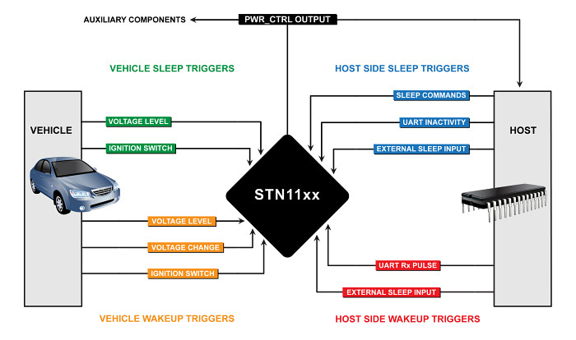

# Audio

The carrier will support audio with the ability to directly drive vehicle speakers. The audio will be generated from audio DAC connected to the SOM and that will drive a high wattage (~50W) audio amplifier circuit.

## DAC

The NXP UDA1334ATS will be DAC used. This is same as the Flipside carrier.

## Power Amplifier

TBD

# Overvoltage protection

# MicroSD

A microSD connector (Molex 5025700893) will be used for development and debugging.

# LCD

The carrier will support a full color LCD screen

## LVDS

The LCD will be driver by the LVDS1 port. This is the same as the Flipside carrier; all connectors will be preserved for easy of driver development.

## LCD Power Supply

The Maxim MAX1531ETJ will be sued to generate all the necessary gamma LCD voltages. This is the same as the Flipside carrier; all connectors will be preserved for easy of driver development.

## LCD Backlight

The Allegro A8514KLP will be used to driver the LCD backlight. This is the same as the Flipside carrier; all connectors will be preserved for easy of driver development.

# System Monitoring

An 8-channel 10-bit SAR ADC (TI TLV1548IDB) will be used for system monitoring. The ADC will sample the following signals:

* Input battery voltage (ie, supply voltage)
* LCD temperature
* Board temperature

## Temperature Sensor

A Microchip MCP9700 analog temperature sensor will be used to monitor the board’s temperature.